Caesar Raishawn Watts-Hall

JAVA 1

December 05, 2018

Dr. Primo

**GROUP PROJECT: *Centurion Currency Calculator***

For the class project, we’ve created a “Currency Calculator”, which you can use to accurately calculate the amount of cash one would receive if they were to travel out of [their] country.

Upon opening the application, you will see four distinct panel boxes written in blue text, ***“From”, “To”, “Enter Amount to Convert”,*** and ***“Here’s the converted amount”*** result box.

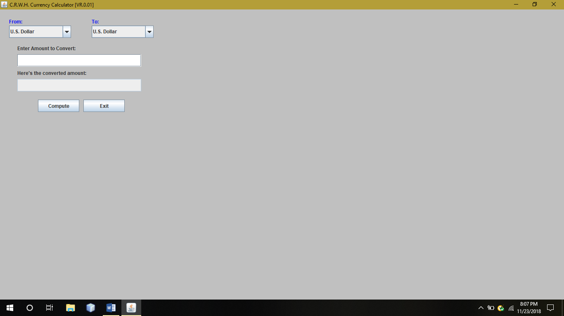

Let’s say that the user was traveling from the U.S. to China and they wanted to know the amount of money that s/he currently has, and what would that be converted into, while being in the new country. Clicking on the drop-down menu box, you will see a list to choose from:

* U.S. Dollar
* Canadian Dollar
* Australian Dollar
* Chinese Yuan,
* Japanese Yen,
* Pound Sterling [Britain’s Currency]
* Euro

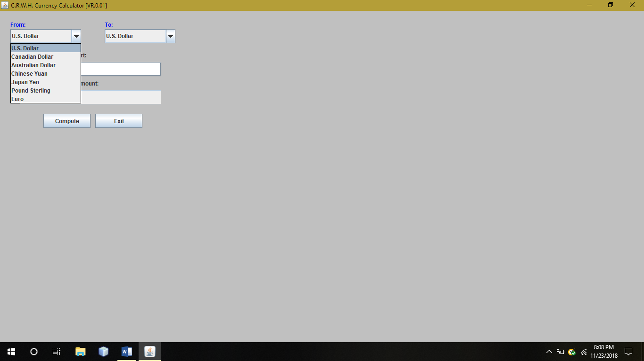

After clicking on the preferred tab *(in this case, the U.S.),* you next, need to click on the ***“To:”*** drop-menu, to find out which country and their currency you would like to convert. The countries remain the same. **(click on the ‘Chinese Yuan’ tab)**

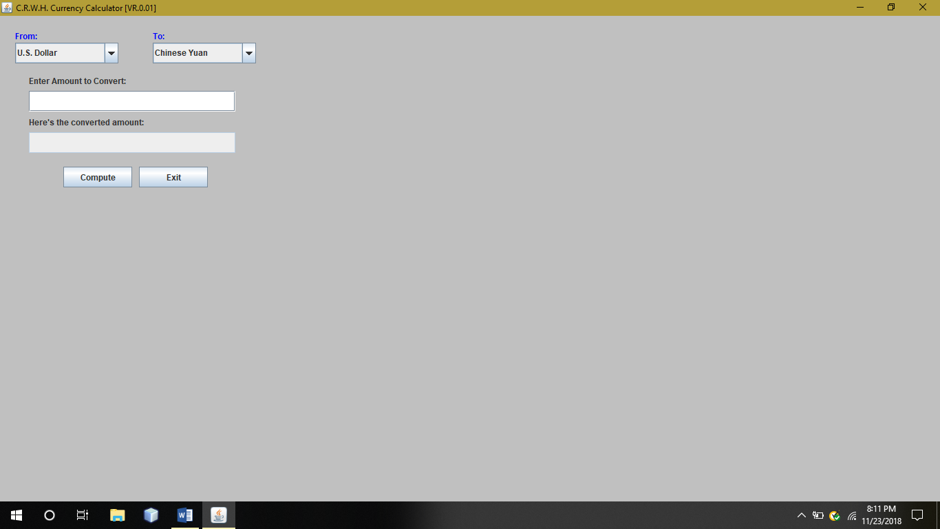

Great! Now since you’ve decided upon a country and their retrospective currency, now you may enter the amount you’d like to see change. In this instance, let’s say the user had exactly $4,000 that they’d like to use for spending money over in their trip. Enter the whole amount **(*Decimal points are necessary if one is bringing change.*** ***In addition,*** ***the dollar sign ($) and commas are not necessary when inputting an amount!***)

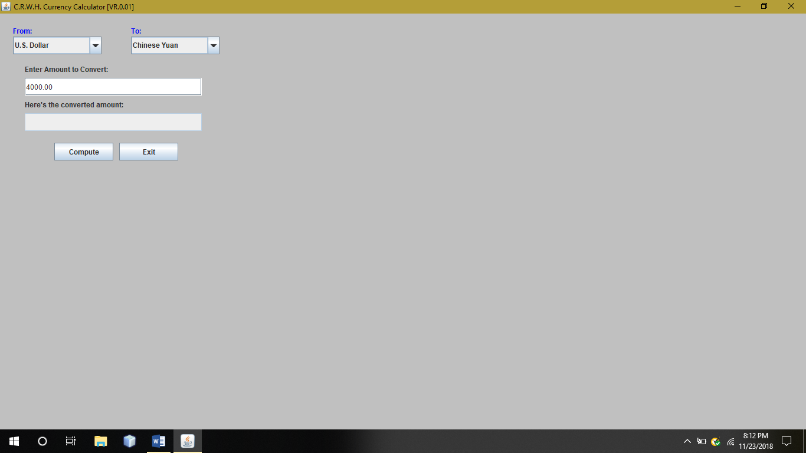

Lastly after pressing the “Compute” button, you will get your accurate amount of exchanged, Chinese currency!

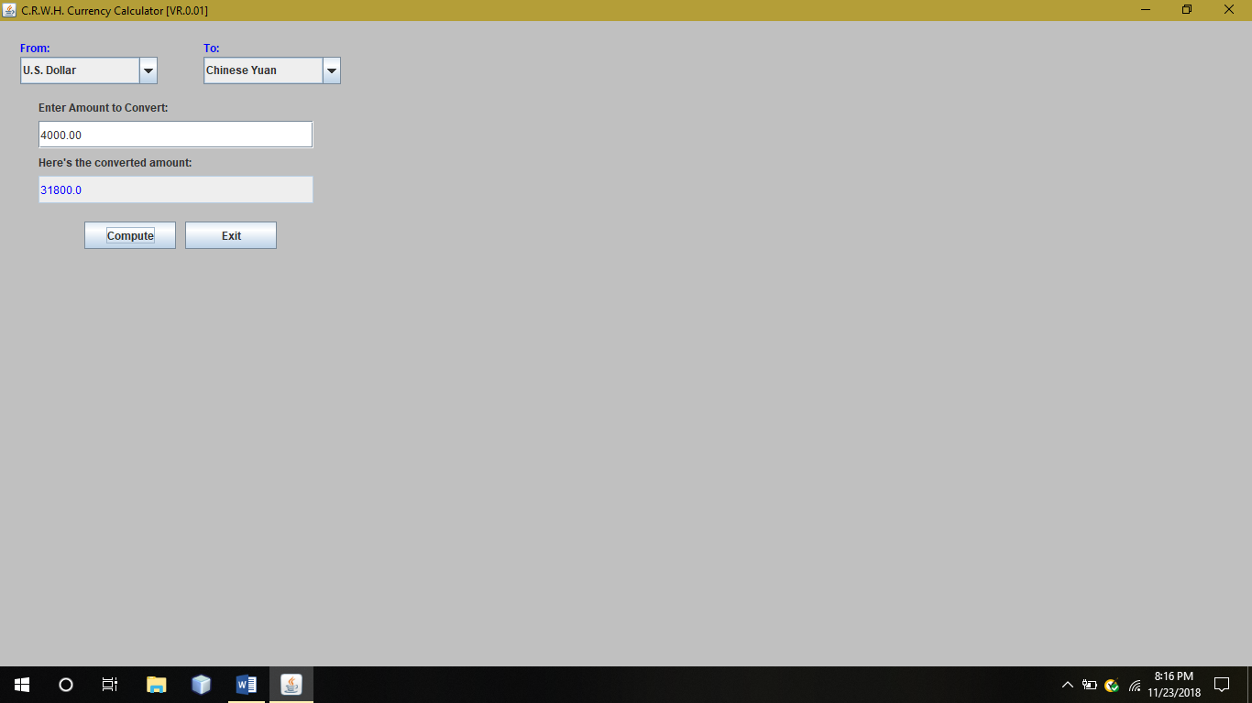

As you can see from the example text above, if the nameless-user has $4,000.00 USD and wanted to travel to China, his accurate exchanged currency will result in ¥31,800.00 Chinese Yuan. You may apply this example to any other of the listed countries, and you will get a different amount, as currency is either more or less of value within every country. I hope you enjoy the Centurion Currency Calculator and **Happy Traveling!**